# SOM-IMX8MM LPD4

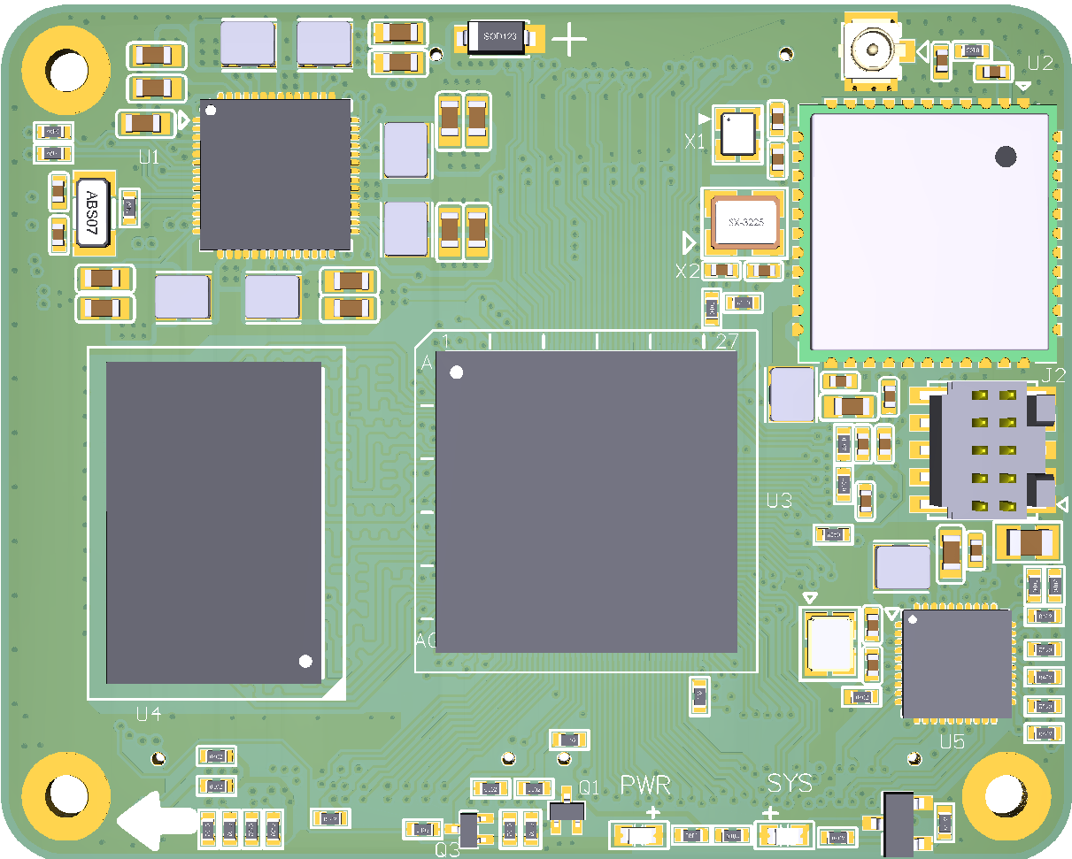

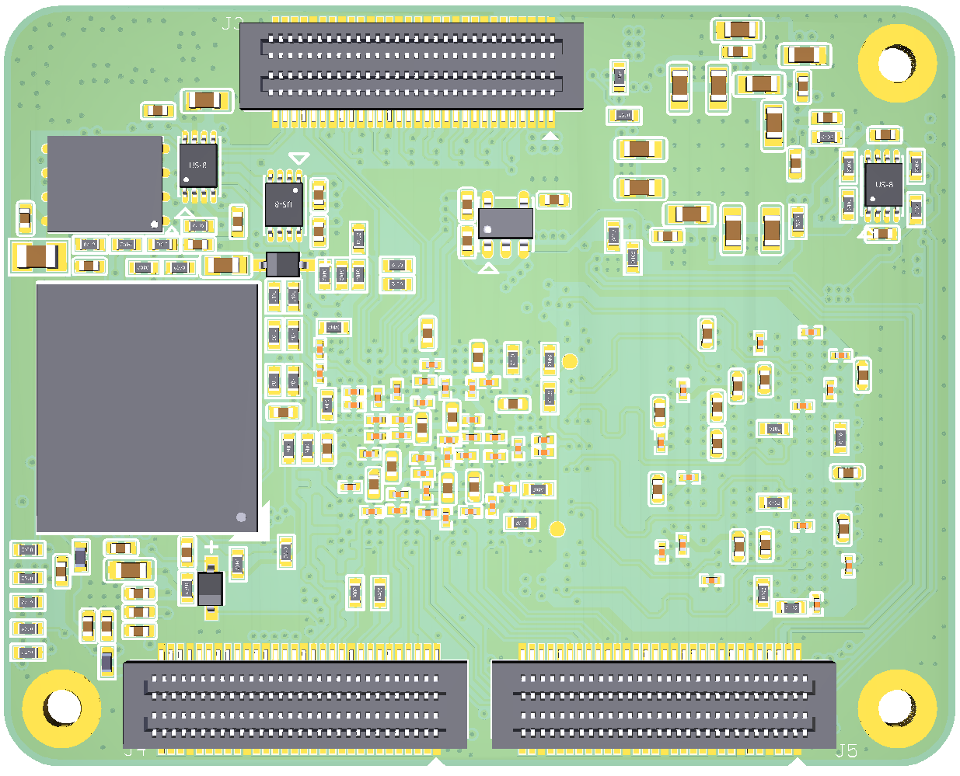

**Contents**

SOM-IMX8MM LPD4 1

1. General 3

2. Features 4

2.1 SOM-IMX8MM LPD4 4

2.2 DEV-IMX8M-MINI 5

3. Application 6

4. Mechanical Dimension 7

5. Electrical Characteristics 8

5.1 Working Temperature 8

6. Hardware Overview 8

6.1 System Components 8

6.2 Functional Block Diagrams 10

7. Interface Description 11

7.1 BTB ON Connector 11

7.2 WiFi/BT Antenna Connector 12

8. Pinout Description Table 13

9. Power Supply And System Resets 20

9.1 Power Source 20

9.2 Power Control and Monitoring 20

9.3 System power 20

9.4 Power Consumption Typical Values 20

10. System Resets 21

10.1 Power-on Reset 21

10.2 Brown-out Reset 21

10.3 Software Reset 21

10.4 External Reset 21

11. Boot Mode 21

12. Trace impedance recommendations 22

13. High-speed signal trace length compensation 22

14. Circuit Example 24

14.1 Reset In 24

14.2 Power Key 24

14.3 Boot Mode 24

14.4 Giga Ethernet 25

14.5 TF Card 26

14.6 SOM Power-Up Enable 27

14.7 PCIe Clock 27

14.8 Serial Download 28

## General

This document describes the hardware architecture of the SOM-IMX8MM LPD4 Module.

The SOM-IMX8MM LPD4 System-On-Module (SOM) board is based on NXP’s energy efficient [i.MX 8M Mini](https://www.nxp.com/imx8mmini) series processor. For i.MX 8M Mini/Nano series processor is which has up to 4 x Cortex-A53 cores capable at running up to 1.8 GHz and one Cortex-M4 core capable at running up to 400 MHz core for low-power and real-time operation.

On-board up to 8GB LPDDR4, up to 64GB eMMC and a WiFi / Bluetooth module, and with MIPI DSI display transmitter, MIPI CSI camera receiver, flexible audio interfaces and comprehensive communication features. The SOM-IMX8MM LPD4 Module is a fully-integrated system that helps you build your professional embedded systems rapidly.

Support Linux kernel, Yocto Project file-system, Debian and Android run on the Cortex-A core, and Real-time OS such as UCOS and FreeRT OS run on the Cortex-M core.

Comes with detailed user manual, ready-made system, and friendly technology support. We are able to provide customize based on this SOM module for [various](D:/Program%20Files%20(x86)/Youdao/Dict/8.9.3.0/resultui/html/index.html#/javascript:;) applications.

## Features

### SOM-IMX8MM LPD4

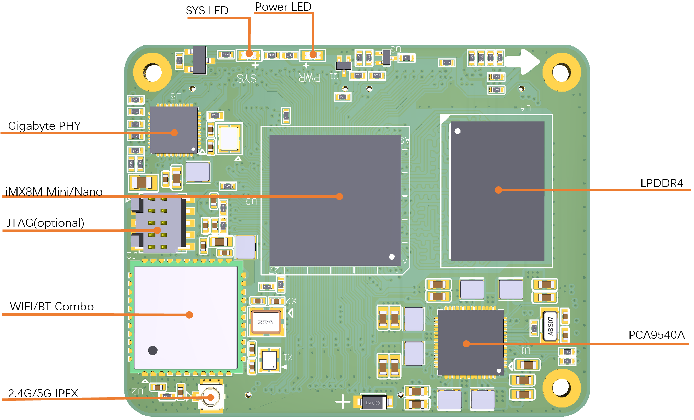

1. Top side of SOM-IMX8MM LPD4

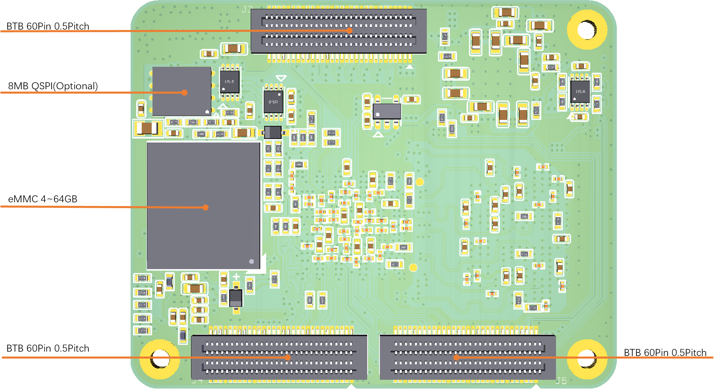

1. Bottom side of SOM-IMX8MM LPD4
   * Up to Quad-core ARM Cortex-A53
   * 64-bit Armv8-A architecture
   * Target frequency up to 1.8GHz
   * 2D/3D GC520L
   * Media Processing Engine (MPE) with NEON technology
   * Floating Point Unit (FPU) with support of the VFPv4-D16 architecture
   * One Cortex-M4 up to 400MHz

* Wi-Fi 1x1 (802.11b/g/n/ac 2.4/5GHz)
* Bluetooth 5.0
* From 4 to 64GB eMMC
* Up to 8GB LPDDR4 (2~4GB are available and 8GB coming soon)
* 64M bit Quad SPI Flash Optional
* 3*60Pin 0.5mm pitch BTB connectors
* Up to 75xGPIO (including SPI, I2C, PWM, UART, SAI, and SDIO)

### DEV-IMX8M-MINI

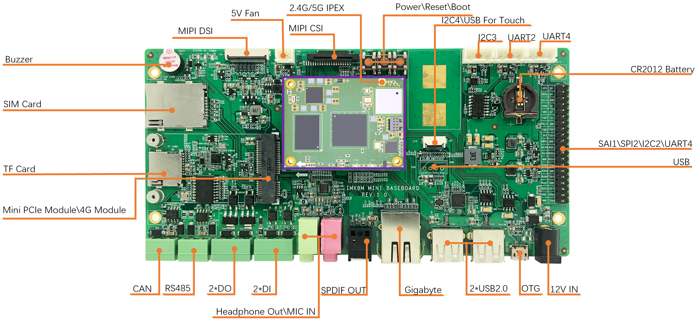

1. DEV-IMX8M-MINI

* 12V Power IN x 1
* USB 2.0 Host x 2
* USB OTG x 1
* USB 2.0 Host (4 Pin Connector) x 1
* UART:
  + UART2 (TTL, For Debug)
  + UART3 (TTL, For User)
  + UART4 (TTL, For User)
* I2C x 3
* USB Touch x 1
* MIPI-CSI x 1
* Fan 5V port x 1
* MIPI-DSI x 1
* Buzzer x 1
* SIM Card x 1
* TF Card x 1
* Mini PCIE Interface x 1, For 4G module and PCIE module
* CAN Bus x 1
* RS485 Bus x 1
* Input Terminal x 2 PIN (With Isolation)
* Output Terminal x 2 PIN (With Isolation)
* Headphone Output/MIC In x 1
* SPDIF Out x 1
* 1x Gigabit Ethernet on-board

## Application

* HMI
* Medical appliances
* Industrial automation
* Weighing Scales
* Smart Toll Systems
* Educational Consoles

## Mechanical Dimension

* Size: 50 x 40 x 7.3 mm
* PCB Parameter：8layer design, lead-free soldering process
* Weight: 12g

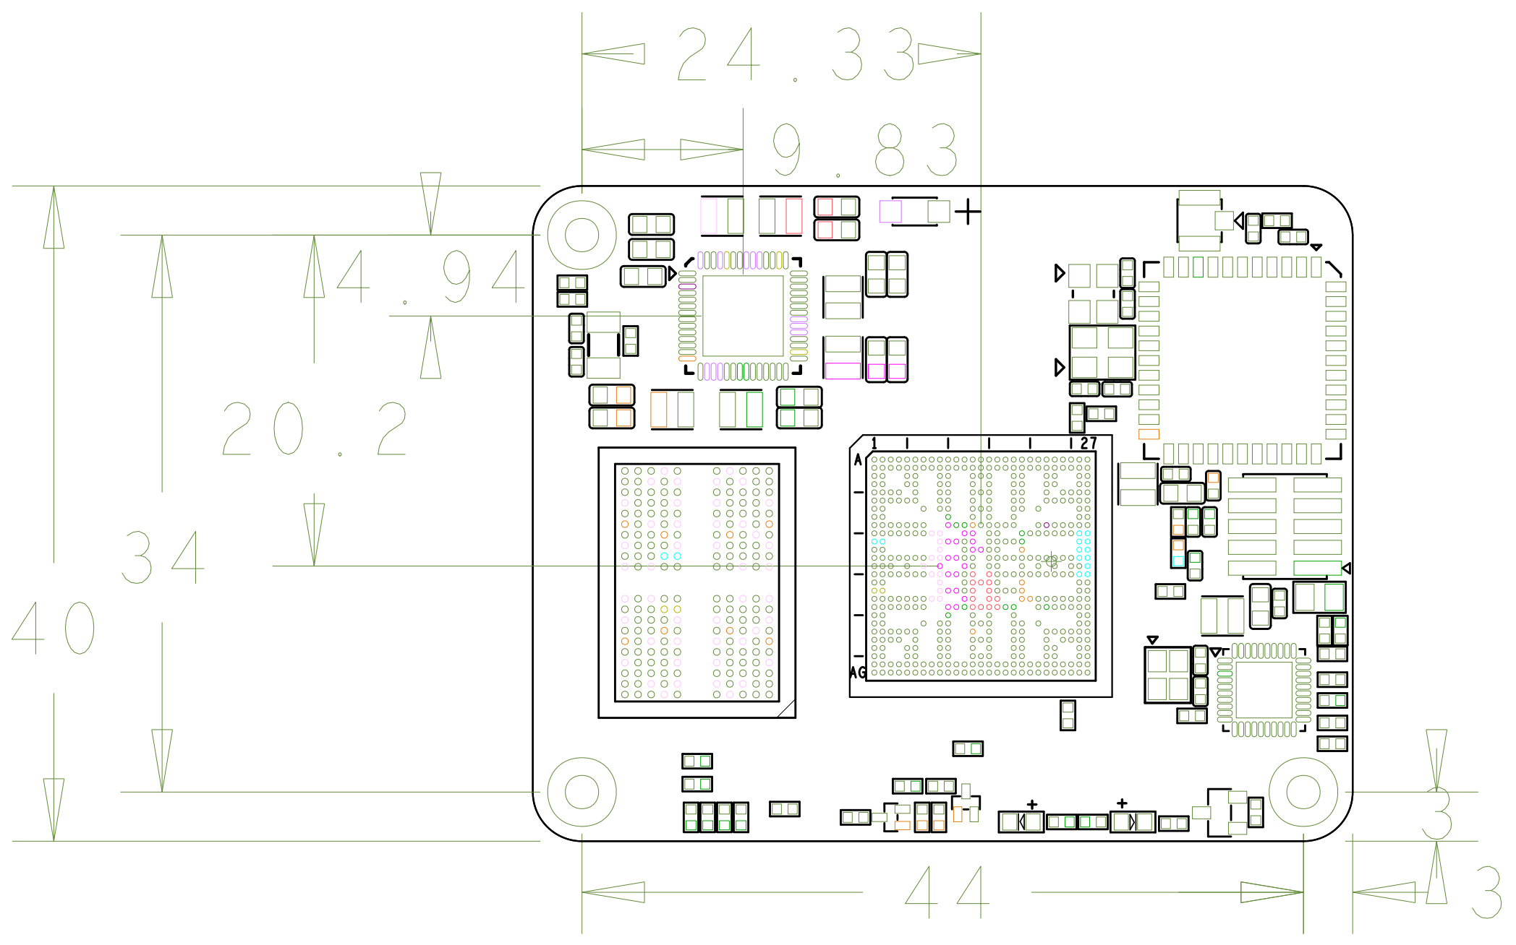

1. Mechanical Dimension of Top side

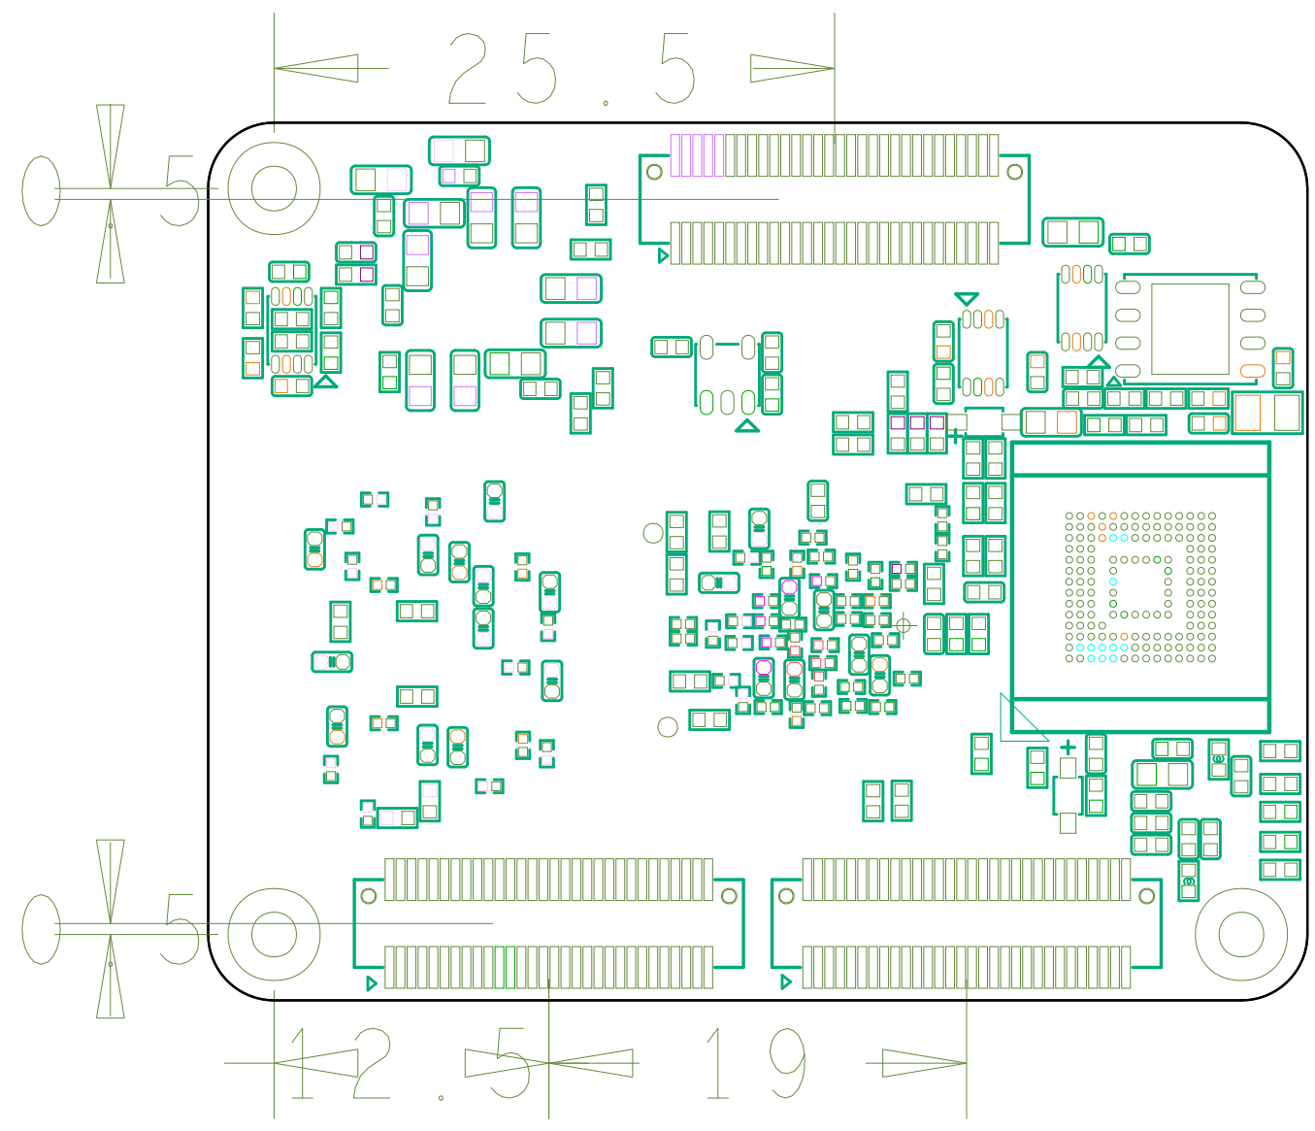

1. Mechanical Dimension of Bottom side

## Electrical Characteristics

### Working Temperature

1. Working Temperature

|  |  |  |
| --- | --- | --- |
| [Specification](D:/Program%20Files%20(x86)/Youdao/Dict/8.9.3.0/resultui/html/index.html#/javascript:;) | [Minimum Operating Temperature](D:/Program%20Files%20(x86)/Youdao/Dict/8.9.3.0/resultui/html/index.html#/javascript:;)  (℃) | [[Maximum](D:/Program%20Files%20(x86)/Youdao/Dict/8.9.3.0/resultui/html/index.html#/javascript:;) Operating Temperature](D:/Program%20Files%20(x86)/Youdao/Dict/8.9.3.0/resultui/html/index.html#/javascript:;)  (℃) |
| Commercial Grade | 0 | 70 |
| [Industrial](D:/Program%20Files%20(x86)/Youdao/Dict/8.9.3.0/resultui/html/index.html#/javascript:;) [Grade](D:/Program%20Files%20(x86)/Youdao/Dict/8.9.3.0/resultui/html/index.html#/javascript:;) | -40 | +85 |

Note:

A heat sink may need for some applications

## Hardware Overview

### System Components

1. Hardware Overview

|  |  |
| --- | --- |
| **Feature** | **Details** |
| **i.MX8M MINI SOC** | |
| Arm Cortex-A53 MPCore platform | Quad symmetric Cortex-A53 processors, including:  • 32 KB L1 Instruction Cache  • 32 KB L1 Data Cache  • Media Processing Engine (MPE)  • Floating Point Unit (FPU)  Support of 64-bit Armv8-A architecture  • 512 KB unified L2 cache  • Target frequency of 1.8GHz |
| Arm Cortex-M4 core platform | • 16 KB L1 Instruction Cache  • 16 KB L1 Data Cache  • 256 KB TCM |
| Graphic Processing Unit (GPU) | • GC NanoUltra frequency up to 800 MHz  • OpenGL ES 2.0  • 2D GC520L |
| Video Processing Unit (VPU) | • VP9,VP8,AVC,H.265,H.264 decoder  • VP8, AVC,H.264 encoder |
| Audio | • S/PDIF Input and Output  • SAI modules supporting I2S,AC97,TDM |
| On-chip memory | • Boot ROM (256KB)  • On-chip RAM (256KB + 32KB) |
| **Memory and storage** | |
| DDR SDRAM | • 2~8GB LPDDR4 SDRAM (2~4GB available, 6GB and 8GB coming soon)  • 1600MHz maximum DDR clock |
| eMMC | • 4~64GB eMMC flash, 16GB by default  • 8-bits MMC mode  • Conforms to JEDEC version 5.0 and 5.1 |
| SPI Flash | • 64M bit SPI flash memory  • 104MHz Single, Dual/Quad SPI clocks  • More than 100,000 erase/program cycles  • More than 20-year data retention |
| Expandable flash (MicroSD) | • Meets SD/SDIO 3.0 standard Runs at 4-bits  • Supports system boot from SD card |
| **Network & Wireless** | |
| Ethernet | • On-board 10/100/1000 Mbps Ethernet PHY |
| Wi-Fi | AzureWave AW-CM256SM module:  • Wi-Fi 1x1 (802.11a/b/g/n/ac 2.4/5GHz)  • SDIO 3.0  • High speed wireless connection up to 433.3Mbps |
| Bluetooth | AzureWave AW-CM256SM module:  • Bluetooth 5.0 (supports Bluetooth low-energy)  • High-speed UART  • PCM audio |
| **Hardware Interface** | |
| I/O connectivity | • 1x single lane PCI Express Gen 2  • 2x USB2.0 OTG with integrated PHY  • 1x SDIO supporting MMC 5.1, SDIO 3.01  • 1x Gigabit Ethernet with integrated PHY  • 3x UART  • 3x I2C  • 2x ESPI |
| Display Interfaces | • 4-lane MIPI DSI interface |
| Camera | • 4-lane MIPI CSI interface |

### Functional Block Diagrams

The following figure is a functional block diagram of the SOM-IMX8MM LPD4:



1. Functional Block Diagrams

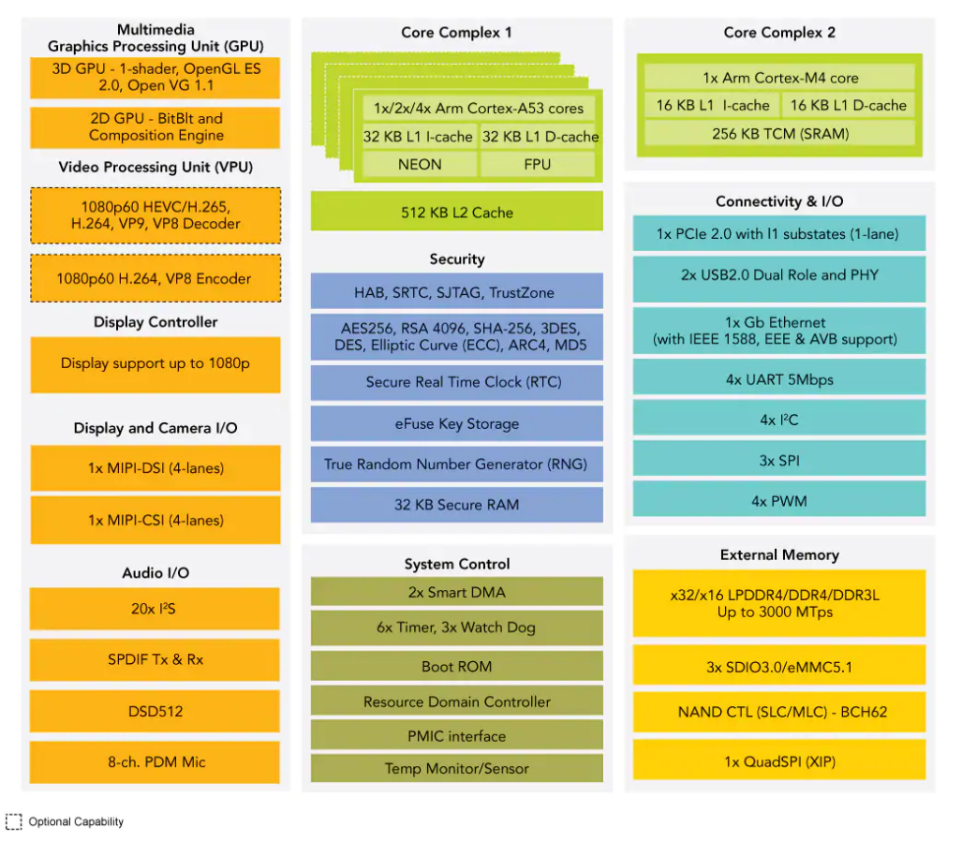

1. i.MX 8M Mini system block diagram

## Interface Description

### BTB ON Connector

The BTB connector mounted on SOM is MB250-G60S-B1R supplied by MTCONN. The specification of the connector is:

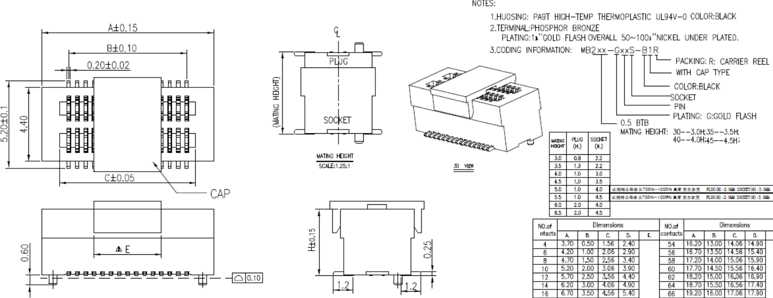

1. Connector Specifications For SOM

The recommended BTB connector can be mounted on baseboard is MB250-G60P-B1R supplied by MTCONN, an equal parameters BTB connector can be used instead. The specification of the connector is as following:

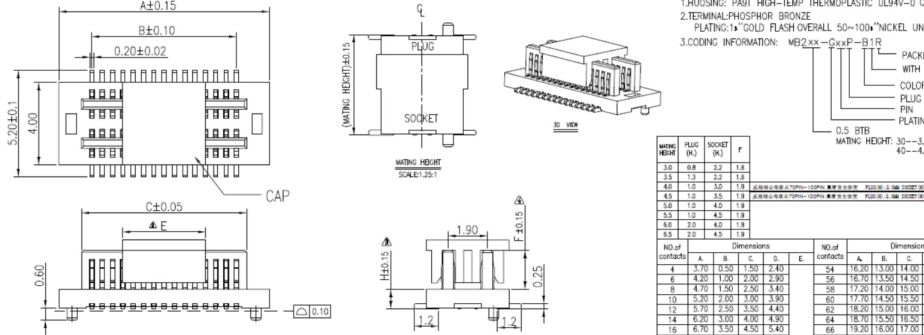

1. Connector Specifications for Baseboard

### WiFi/BT Antenna Connector

The antenna connector mounted on SOM is Ultra Small Surface Mount Coaxial Connector, the detail of the connector is as following:

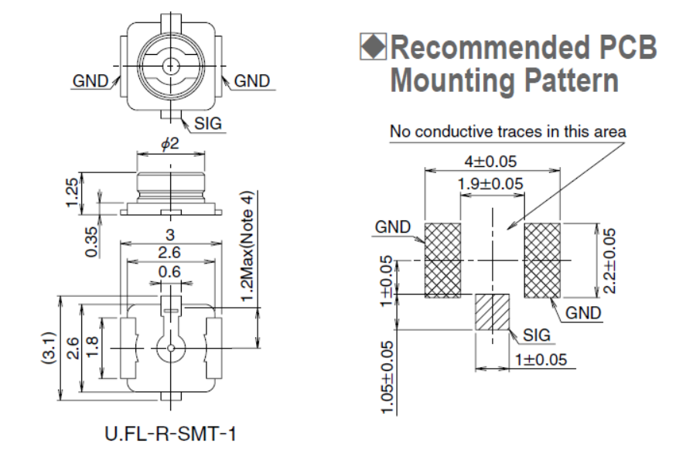

1. Specifications For UFL

## Pinout Description Table

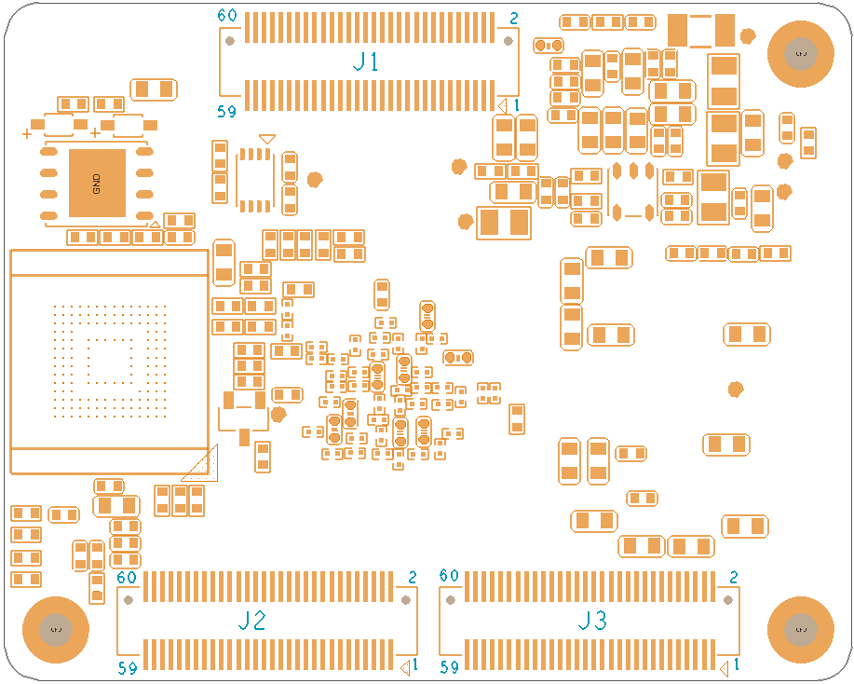

1. Assemble BTB on bottom side of SOM-IMX8MM LPD4



1. Pin out of J1
2. Pin Definition of J1

| **J1** | | | | | |
| --- | --- | --- | --- | --- | --- |
| **Number** | **Signal** | **Power Logic** | **Input/Output** | **CPU Ball** | **Note** |
| 1 | GND |  |  |  |  |
| 2 | 5V_IN |  | Power In |  |  |
| 3 | GND |  |  |  |  |
| 4 | 5V_IN |  | Power In |  |  |
| 5 | GND |  |  |  |  |
| 6 | 5V_IN |  | Power In |  |  |
| 7 | DSI_DN0 | MIPI DSI |  | A9 |  |
| 8 | 5V_IN |  | Power In |  |  |
| 9 | DSI_DP0 | MIPI DSI |  | B9 |  |
| 10 | 5V_IN |  | Power In |  |  |
| 11 | GND |  |  |  |  |
| 12 | DSI_DN1 | MIPI DSI | Output | A10 |  |
| 13 | DSI_CKN | MIPI DSI | Output | A11 |  |
| 14 | DSI_DP1 | MIPI DSI | Output | B10 |  |
| 15 | DSI_CKP | MIPI DSI | Output | B11 |  |
| 16 | GND |  |  |  |  |
| 17 | GND |  |  |  |  |
| 18 | DSI_DN2 | MIPI DSI | Output | A12 |  |
| 19 | DSI_DN3 | MIPI DSI | Output | A13 |  |
| 20 | DSI_DP2 | MIPI DSI | Output | B12 |  |
| 21 | DSI_DP3 | MIPI DSI | Output | B13 |  |
| 22 | GND |  |  |  |  |
| 23 | GND |  |  |  |  |
| 24 | CSI_DN0 | MIPI CSI | Input | A14 |  |
| 25 | CSI_DN1 | MIPI CSI | Input | A15 |  |
| 26 | CSI_DP0 | MIPI CSI | Input | B14 |  |
| 27 | CSI_DP1 | MIPI CSI | Input | B15 |  |
| 28 | GND |  |  |  |  |
| 29 | GND |  |  |  |  |
| 30 | CSI_CKN | MIPI CSI | Input | A16 |  |
| 31 | CSI_DN2 | MIPI CSI | Input | A17 |  |
| 32 | CSI_CKP | MIPI CSI | Input | B16 |  |
| 33 | CSI_DP2 | MIPI CSI | Input | B17 |  |
| 34 | GND |  |  |  |  |
| 35 | GND |  |  |  |  |
| 36 | CSI_DN3 | MIPI CSI | Input | A18 |  |
| 37 | PCIE_RX_N | PCIe | Input | A19 |  |
| 38 | CSI_DP3 | MIPI CSI | Input | B18 |  |
| 39 | PCIE_RX_P | PCIe | Input | B19 |  |
| 40 | GND |  |  |  |  |
| 41 | GND |  |  |  |  |
| 42 | PCIE_TX_N | PCIe | Output | A20 |  |
| 43 | PCIE_CLK_N | PCIe | Input | A21 |  |
| 44 | PCIE_TX_P | PCIe | Output | B20 |  |
| 45 | PCIE_CLK_P | PCIe | Input | B21 |  |
| 46 | GND |  |  |  |  |
| 47 | GND |  |  |  |  |
| 48 | USB1_DN | USB | In/Out | A22 |  |
| 49 | UART4_TXD | 3.3V | In/Out | F18 | M4 Debug UART |
| 50 | USB1_DP | USB | In/Out | B22 |  |
| 51 | UART4_RXD | 3.3V | In/Out | F19 | M4 Debug UART |
| 52 | GND |  |  |  |  |
| 53 | USB1_ID | 1.8V | Input | D22 | Connected to GND or Unconnected |
| 54 | USB2_DN | USB | In/Out | A23 |  |
| 55 | USB1_VBUS | USB | Power Detect | F22 | Connect USB 5V |
| 56 | USB2_DP | USB | In/Out | B23 |  |
| 57 | USB2_VBUS | USB | Power Detect | F23 | Connect USB 5V |
| 58 | BOOT_MODE0 | 3.3V | Input | G26 |  |
| 59 | GND |  |  |  |  |
| 60 | BOOT_MODE1 | 3.3V | Input | G27 | 10K pull-up 3.3V |

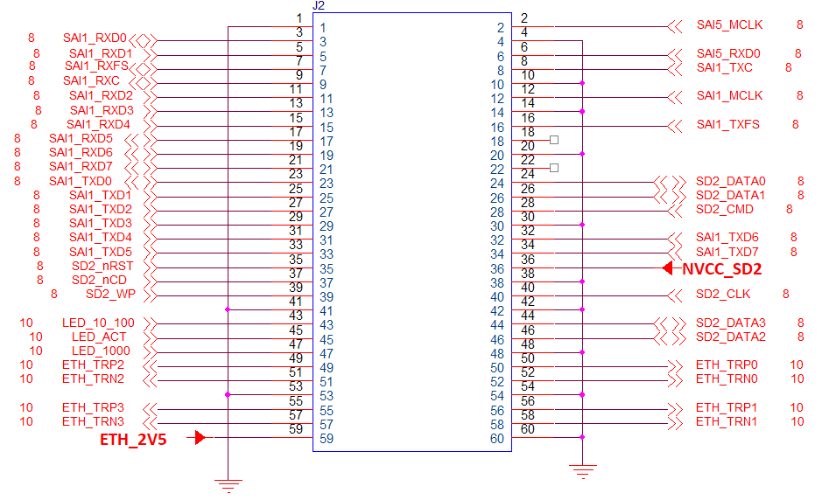

1. Pin out of J2
2. Pin Definition of J2

| J2 | | | | | |
| --- | --- | --- | --- | --- | --- |
| **Number** | **Signal** | **Power Logic** | **Input/Output** | **CPU Ball** | **Note** |
| 1 | GND |  |  |  |  |
| 2 | SAI5_MCLK | 3.3V | In/Out | AD15 |  |
| 3 | SAI1_RXD0 | 3.3V | In/Out | AG15 | Boot CFG 0 |
| 4 | GND |  |  |  |  |
| 5 | SAI1_RXD1 | 3.3V | In/Out | AF15 | Boot CFG 1 |
| 6 | SAI5_RXD0 | 3.3V | In/Out | AD18 |  |
| 7 | SAI1_RXFS | 3.3V | In/Out | AG16 |  |
| 8 | SAI1_TXC | 3.3V | In/Out | AC18 |  |
| 9 | SAI1_RXC | 3.3V | In/Out | AF16 |  |
| 10 | GND |  |  |  |  |
| 11 | SAI1_RXD2 | 3.3V | In/Out | AG17 | Boot CFG 2 |
| 12 | SAI1_MCLK | 3.3V | In/Out | AB18 |  |
| 13 | SAI1_RXD3 | 3.3V | In/Out | AF17 | Boot CFG 3 |
| 14 | GND |  |  |  |  |
| 15 | SAI1_RXD4 | 3.3V | In/Out | AG18 | Boot CFG 4 |
| 16 | SAI1_TXFS | 3.3V | In/Out | AB19 |  |
| 17 | SAI1_RXD5 | 3.3V | In/Out | AF18 | Boot CFG 5 |
| 18 | NC |  |  |  | No connection |
| 19 | SAI1_RXD6 | 3.3V | In/Out | AG19 | Boot CFG 6 |
| 20 | GND |  |  |  | No Connection |
| 21 | SAI1_RXD7 | 3.3V | In/Out | AF19 | Boot CFG 7 |
| 22 | NC |  |  |  |  |
| 23 | SAI1_TXD0 | 3.3V | In/Out | AG20 | Boot CFG 8 |
| 24 | SD2_DATA0 | NVCC_SD2 | In/Out | AB23 |  |
| 25 | SAI1_TXD1 | 3.3V | In/Out | AF20 | Boot CFG 9 |
| 26 | SD2_DATA1 | NVCC_SD2 | In/Out | AB24 |  |
| 27 | SAI1_TXD2 | 3.3V | In/Out | AG21 | Boot CFG 10 |
| 28 | SD2_CMD | NVCC_SD2 | In/Out | W24 |  |
| 29 | SAI1_TXD3 | 3.3V | In/Out | AF21 | Boot CFG 11 |
| 30 | GND |  |  |  |  |
| 31 | SAI1_TXD4 | 3.3V | In/Out | AG22 | Boot CFG 12 |
| 32 | SAI1_TXD6 | 3.3V | In/Out | AG23 | Boot CFG 14 |
| 33 | SAI1_TXD5 | 3.3V | In/Out | AF22 | Boot CFG 13 |
| 34 | SAI1_TXD7 | 3.3V | In/Out | AF23 | Boot CFG 15 |
| 35 | SD2_RESET_B | NVCC_SD2 | In/Out | AB26 |  |
| 36 | NVCC_SD2 |  | Power output |  |  |
| 37 | SD2_CD_B | NVCC_SD2 | In/Out | AA26 |  |
| 38 | GND |  |  |  |  |
| 39 | SD2_WP | NVCC_SD2 | In/Out | AA27 |  |
| 40 | SD2_CLK | NVCC_SD2 | In/Out | W23 |  |
| 41 | GND |  |  |  |  |
| 42 | GND |  |  |  |  |
| 43 | LED_10_100 | ETH _2V5 | In/Out | 24 | AR8035 |
| 44 | SD2_DATA3 | NVCC_SD2 | In/Out | V23 |  |
| 45 | LED_ACT | ETH _2V5 | In/Out | 21 | AR8035 |
| 46 | SD2_DATA2 | NVCC_SD2 | In/Out | V24 |  |
| 47 | LED_1000 | ETH _2V5 | In/Out | 22 | AR8035 |
| 48 | GND |  |  |  |  |
| 49 | ETH_TRP2 | Analog | In/Out | 15 | AR8035 |
| 50 | ETH _TRP0 | Analog | In/Out | 9 | AR8035 |
| 51 | ETH _TRN2 | Analog | In/Out | 16 | AR8035 |
| 52 | ETH _TRN0 | Analog | In/Out | 10 | AR8035 |
| 53 | GND |  |  |  |  |
| 54 | GND |  |  |  |  |
| 55 | ETH _TRP3 | Analog | In/Out | 18 | AR8035 |
| 56 | ETH _TRP1 | Analog | In/Out | 12 | AR8035 |
| 57 | ETH _TRN3 | Analog | In/Out | 19 | AR8035 |
| 58 | ETH _TRN1 | Analog | In/Out | 13 | AR8035 |
| 59 | ETH _2V5 |  | Power output |  | Just for Ethernet LED |
| 60 | GND |  |  |  |  |



1. Pin out of J3
2. Pin Definition of J3

| J3 | | | | | |
| --- | --- | --- | --- | --- | --- |
| **Number** | **Signal** | **Power Logic** | **Input/Output** | **CPU Ball** | **Note** |
| 1 | GND |  |  |  |  |
| 2 | GND |  |  |  |  |
| 3 | I2C4_SDA | 3.3V | In/Out | E13 | 4.7K pull-up 3.3V |
| 4 | ESPI2_MISO | 3.3V | In/Out | A8 |  |
| 5 | I2C4_SCL | 3.3V | In/Out | D13 | 4.7K pull-up 3.3V |
| 6 | ESPI2_MOSI | 3.3V | In/Out | B8 |  |
| 7 | GND |  |  |  |  |
| 8 | ESPI2_SCLK | 3.3V | In/Out | E6 |  |
| 9 | I2C2_SDA | 3.3V | In/Out | D9 | 4.7K pull-up 3.3V |
| 10 | ESPI2_SS0 | 3.3V | In/Out | A6 |  |
| 11 | I2C2_SCL | 3.3V | In/Out | D10 | 4.7K pull-up 3.3V |
| 12 | GND |  |  |  |  |
| 13 | GND |  |  |  |  |
| 14 | PWR_KEY |  | Input | A25 | 100K pull-up 1.8V |
| 15 | I2C3_SDA | 3.3V | In/Out | F10 | 4.7K pull-up 3.3V |
| 16 | RESET |  | Input | 40 | BD71847MWV |
| 17 | I2C3_SCL | 3.3V | In/Out | E10 | 4.7K pull-up 3.3V |
| 18 | GND |  |  |  |  |
| 19 | GND |  |  |  |  |
| 20 | UART3_RXD | 3.3V | In/Out | D6 |  |
| 21 | VDD_3V3 |  | Power output |  |  |
| 22 | UART3_RTS | 3.3V | In/Out | B6 |  |
| 23 | VDD_3V3 |  | Power output |  |  |
| 24 | UART3_TXD | 3.3V | In/Out | B7 |  |
| 25 | SAI3_TXC | 3.3V | In/Out | AG6 |  |
| 26 | UART3_CTS | 3.3V | In/Out | A7 |  |
| 27 | SAI3_TXD | 3.3V | In/Out | AF6 |  |
| 28 | GND |  |  |  |  |
| 29 | GND |  |  |  |  |
| 30 | GND |  |  |  |  |
| 31 | SAI3_RXC | 3.3V | In/Out | AG7 |  |
| 32 | GPIO1_IO15 | 3.3V | In/Out | AB9 |  |
| 33 | SAI3_RXD | 3.3V | In/Out | AF7 |  |
| 34 | GPIO1_IO14 | 3.3V | In/Out | AC9 |  |
| 35 | SAI3_RXFS | 3.3V | In/Out | AG8 |  |
| 36 | SAI3_TXFS | 3.3V | In/Out | AC6 |  |
| 37 | GND |  |  |  |  |
| 38 | GND |  |  |  |  |
| 39 | SPDIF_EXT_CLK | 3.3V | In/Out | AF8 |  |
| 40 | SAI3_MCLK | 3.3V | In/Out | AD6 |  |
| 41 | SPDIF_RX | 3.3V | In/Out | AG9 |  |
| 42 | GND |  |  |  |  |
| 43 | SPDIF_TX | 3.3V | In/Out | AF9 |  |
| 44 | GPIO1_IO13 | 3.3V | In/Out | AD9 |  |
| 45 | GPIO1_IO08 | 3.3V | In/Out | AG10 |  |
| 46 | GPIO1_IO12 | 3.3V | In/Out | AB10 |  |
| 47 | GPIO1_IO09 | 3.3V | In/Out | AF10 |  |
| 48 | GPIO1_IO10 | 3.3V | In/Out | AD10 |  |
| 49 | GPIO1_IO06 | 3.3V | In/Out | AG11 |  |
| 50 | SAI5_RXD2 | 3.3V | In/Out | AD13 |  |
| 51 | GPIO1_IO05 | 3.3V | In/Out | AF12 |  |
| 52 | SAI5_RXC | 3.3V | In/Out | AC15 |  |
| 53 | GPIO1_IO01 | 3.3V | In/Out | AF14 |  |
| 54 | SAI5_RXFS | 3.3V | In/Out | AB15 |  |
| 55 | GND |  |  |  |  |
| 56 | SAI5_RXD1 | 3.3V | In/Out | AC14 |  |
| 57 | UART2_TXD | 3.3V | In/Out | E15 | A53 Debug UART |
| 58 | SAI5_RXD3 | 3.3V | In/Out | AC13 |  |
| 59 | UART2_RXD | 3.3V | In/Out | F15 | A53 Debug UART |
| 60 | GND |  |  |  |  |

GPIO1_IO05: During reset: output high without PU/PD; After reset: input with PU

SAI5_CLK: During reset: input without PU/PD; After reset: input with PD

## Power Supply And System Resets

### Power Source

The SOM-IMX8MM LPD4 have built-in power management function, so it is only need to provide a +5V power source to the SOM-IMX8MM LPD4 via the 5V input pins of the J1 connector.

It is high suggest that the baseboard to supply the power consumption **2A/5V(10W)** for the SOM-IMX8MM LPD4 board to be working properly.

### Power Control and Monitoring

Power control and monitoring on the SOM-IMX8MM LPD4 is implemented using the NXP Power Control Integrated Circuit (PMIC) PCA9450, designed specifically for the NXP i.MX8M MINI/Nano family of application processors.

The PCA9450 provides Dynamic Voltage Scaling via I²C bus. The PMIC is accessible on the i.MX8M I2C1 bus and the read and write addresses are 0x4B and 0x4A, respectively. The slave address for PCA9450 is 0x25.

### System power

The SOM requires 5V as power input (at 5V_IN). The SOM then generates the power rails for all SOM components through the on-board ICs. Tolerance for power supply is 5V +/- 0.3V.

**Caution:**

1. Do not connect the ETH _2V5/ VDD_3V3/ NVCC_SD2 power output pins to any high current devices or you might brownout the system. These power lines are shared with internal SOM circuits, so there is no safe limit for a high current device, but you can safely use them for low current tasks such as for a level shifter or pullup/down.
2. Do not connect any of the 3.3V I/O pins to a device that draws more than 82 mA of power or you will brownout the system.
3. You must provide a cooling solution to ensure the SOM surface maintains an operational temperature as specified in the environmental reliability section. You can use the SOM's threaded standoffs to mount a passive or active cooling solution.

### Power Consumption Typical Values

The following table lists the power draw for certain SOM components during different operational tests.

It is only a reference value, the actual values also relate to the sources of the SOM module you are using.

1. Power Consumption

|  |  |
| --- | --- |
| **Operational Test** | **SOM Power Values** |
| **Sleep** |  |
| **Idel** |  |
| **High Performance** |  |

## System Resets

### Power-on Reset

This type of reset occurs when the power supply is initially applied to the SOM-IMX8MM LPD4. As the supply voltage rises, the on-board PMIC holds the i.MX 8M MINI in reset until all the processor power supply voltages have risen above the appropriate voltage thresholds (90% of the nominal values). The internal power-on reset generation is disabled.

### Brown-out Reset

In case any processor supply falls below/rises above its 80%/130% of its nominal voltage level, the PMIC generates a reset for the i.MX 8M MINI. After the brown-out reset has occurred, the PMIC holds the i.MX 8M in reset until all the supplies return to the range 90-110% of their nominal values.

### Software Reset

This type of reset is activated by software running on the SOM through performing the i.MX 8M MINI software reset sequence.

### External Reset

To activate this type of reset, a baseboard drives low the SYS_nRST signal on the SOM-IMX8MM LPD4 interface connectors. Activating this signal leads to the i.MX8M MINI SOM power cycle.

## Boot Mode

Use the BOOT_MODE[1:0] pins to configure the SOM boot mode setting as indicated in the following tables. The default configure is Internal boot.

1. Boot Mode

|  |  |  |
| --- | --- | --- |
| **BOOT_MODE1** | **BOOT_MODE0** | **Boot type** |
| 0 | 0 | Boot from fuses |
| 0 | 1 | Serial downloader |
| **1** | **0** | **Internal boot, BOOT CFG[15:0] are used to configure the boot options.** |
| 1 | 1 | Reserved |

The boot configuration is specified by the iMX8M MINI SOC, so for more details, refer to the iMX8M MINI SOC documentation.

## Trace impedance recommendations

The following table lists the recommended impedance for high-speed signals on the baseboard.

1. Trace Impedance Recommendation

|  |  |  |
| --- | --- | --- |
| **Signal group** | **Impedance** | **PCB manufacture tolerance** |
| All single-ended signal,unless specified | 50 Ohm single-ended | +/-10% |
| PCIe TX/RX data pair | 85 Ohm differential | +/-10% |
| PCIe differential clocks | 100 Ohm differential | +/-10% |
| USB differential signals | 90 Ohm differential | +/-10% |
| Ethernet Differential signals | 100 Ohm differential | +/-10% |
| MIPI DSI | 100 Ohm differential | +/-10% |
| MIPI CSI | 100 Ohm differential | +/-10% |

## High-speed signal trace length compensation

The following table lists the trace length of high-speed signals, including MIPI CSI, MIPI DSI, PCIE, USB and Giga Ethernet. Those signals are high-speed signals that require the total etched trace lengths to be equal to each other. Due to space constraints on the SOM, the trace length of those signals currently are not equal. The designer must incorporate the length difference on the baseboard such that the trace length for all high-speed signals match each other.

1. Trace Length Compensation Of SOM

|  |  |  |
| --- | --- | --- |
| **Name** | **Etch length(mils)** | **Manhattan length(mils)** |
| **MIPI CSI** | | |
| CSI_CKN | 648.69 | 602.09 |
| CSI_CKP | 652.53 | 634.84 |
| CSI_DN0 | 660.12 | 621.78 |
| CSI_DP0 | 664.04 | 621.78 |
| CSI_DN1 | 499.98 | 464.3 |
| CSI_DP1 | 504.4 | 464.31 |
| CSI_DN2 | 492.11 | 444.62 |
| CSI_DP2 | 490.91 | 477.36 |
| CSI_DN3 | 639.01 | 615.15 |
| CSI_DP3 | 643.82 | 654.53 |
| **MIPI DSI** | | |
| DSI_CKN | 515.05 | 503.66 |
| DSI_CKP | 519.04 | 503.67 |
| DSI_DN0 | 510.88 | 523.35 |
| DSI_DP0 | 515.6 | 523.35 |
| DSI_DN1 | 653.06 | 661.15 |
| DSI_DP1 | 657.2 | 661.15 |
| DSI_DN2 | 665.93 | 641.46 |
| DSI_DP2 | 668.04 | 641.47 |
| DSI_DN3 | 511.74 | 483.98 |
| DSI_DP3 | 516.23 | 483.98 |
| **PCIe** | | |
| PCIE_CLK_N | 495.48 | 477.35 |
| PCIE_CLK_P | 495.7 | 516.73 |
| PCIE_RX_N | 475.14 | 457.67 |
| PCIE_RX_P | 487.48 | 497.04 |
| PCIE_TX_N | 623.25 | 634.84 |
| PCIE_TX_P | 649.18 | 674.21 |
| **USB1** | | |
| USB1_DN | 647.78 | 654.52 |
| USB1_DP | 652.37 | 693.9 |
| **USB2** | | |
| USB2_DN | 676.18 | 693.89 |
| USB2_DP | 680.79 | 733.26 |
| **Ethernet** | | |
| ETH_TRN0 | 246.14 | 172.62 |
| ETH_TRP0 | 250.02 | 208.05 |
| ETH_TRN1 | 225.73 | 145.06 |
| ETH_TRP1 | 225.39 | 149 |
| ETH_TRN2 | 373.36 | 408.84 |
| ETH_TRP2 | 377.4 | 412.78 |
| ETH_TRN3 | 348.17 | 397.03 |
| ETH_TRP3 | 350.36 | 400.97 |

## Circuit Example

### Reset In

For the reset pin J3.16, a reset button to pull this pin to ground to reset core board is necessary, the ESD component and bypass capacitor is used according to the actual design, a resistor pull up to power supply is installed on SOM board, so not any resistors pull up/down is need.

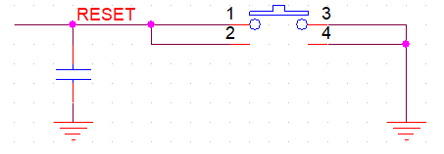

1. Reset In

### Power Key

For the power pin J3.14, assert this pin to ground to indicate a power event. Long press to turn off the SOM board and short press to turn on the SOM board. The ESD component and bypass capacitor is used according to the actual design, a resistor pull up to power supply is installed on SOM board, so not any resistors pull up/down is need.

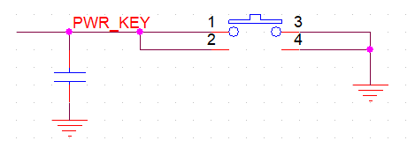

1. Power Key

### Boot Mode

The power used for pull up resistors for boot configuration should source from SOM board to avoid any unpredictable failure. The power output pins are J3.21 and J3.23.

The following figure shows to boot up from eMMC on SOM board.

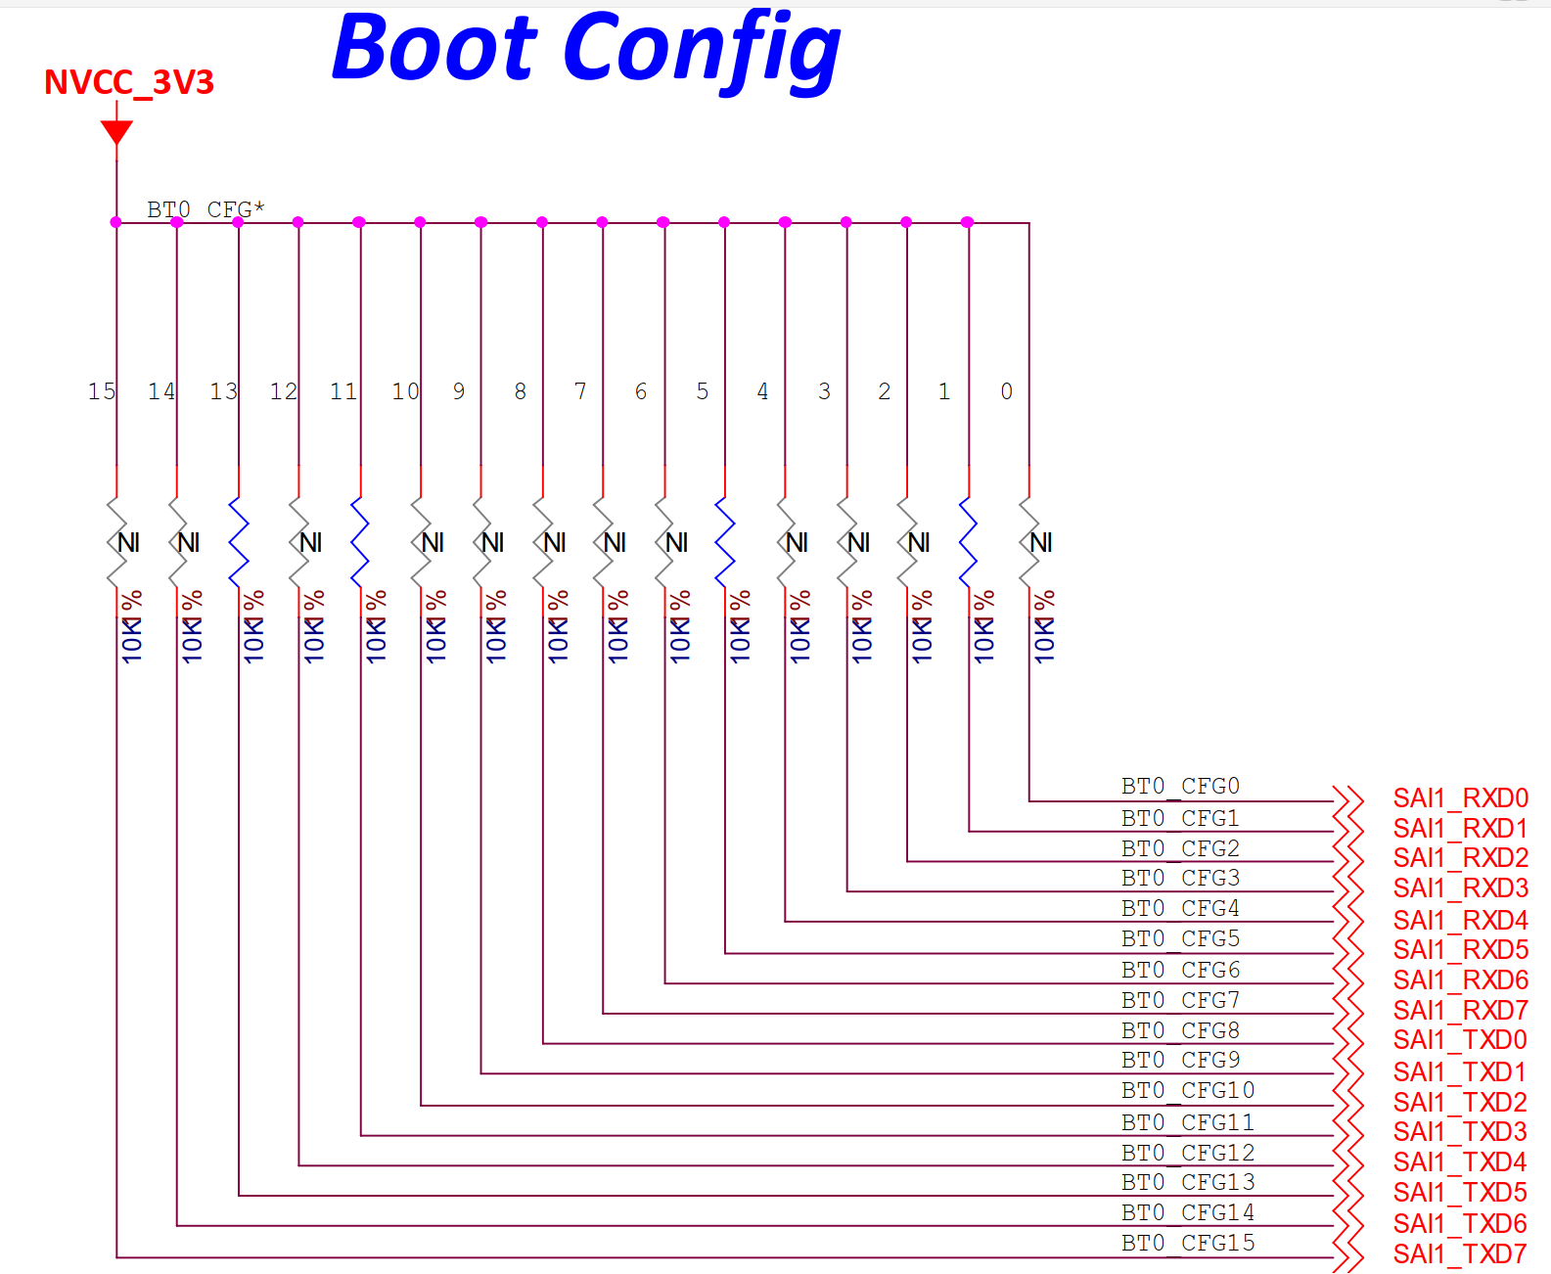

1. Boot up from the eMMC on SOM

If the designer desires to boot the board up from any other storage device, please refer the following table to change the boot-up configuration, further information please refer to [**i.MX 8M Mini Applications Processor Reference Manual**](https://www.nxp.com/webapp/Download?colCode=IMX8MMRM)**.**

**Caution:** The pull-up resistor of boot configuration should be connected to NVCC_3V3 from J3.

On-board eMMC: Connected to uSDHC3 8 bit

TF single on BTB connector: Connected to uSDHC2

On-board QSPI Flash: Connected to QSPI, 1.8V 64M bit QSPI flash, W25Q64FW



1. Table For Boot Configure

### Giga Ethernet

Use a 0.1uF capacitor as bypass capacitor connect to TCT and RCT of the transformer but do not connect these pins to any power supply.

The 49.9R and capacitor matching networks are not necessary to the differential network. The designer should decide using these resistors and capacitors or not according to their design.

For LED_ACT Pin that is J2.45, parallel LED output for 10/100/1000 BASE-T activity, active blinking. LED active low and is 3.3V tolerated.

For LED_1000 Pin that is J2.47, parallel LED output for 1000 BASE-T link, LED active low and is 3.3V tolerated.

For LED_10_100 Pin that is J2.43, parallel LED output for 10/100 BASE-T link. LED active low and is 3.3V tolerated.

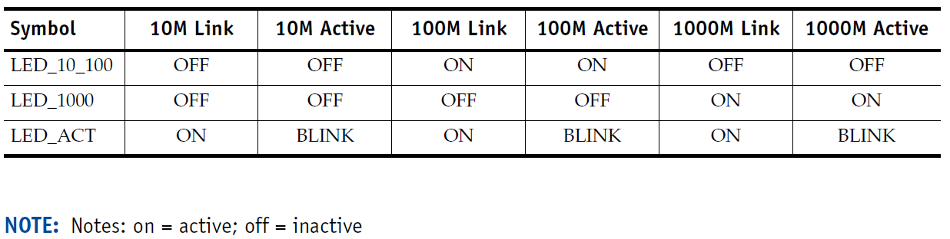

1. LED Status

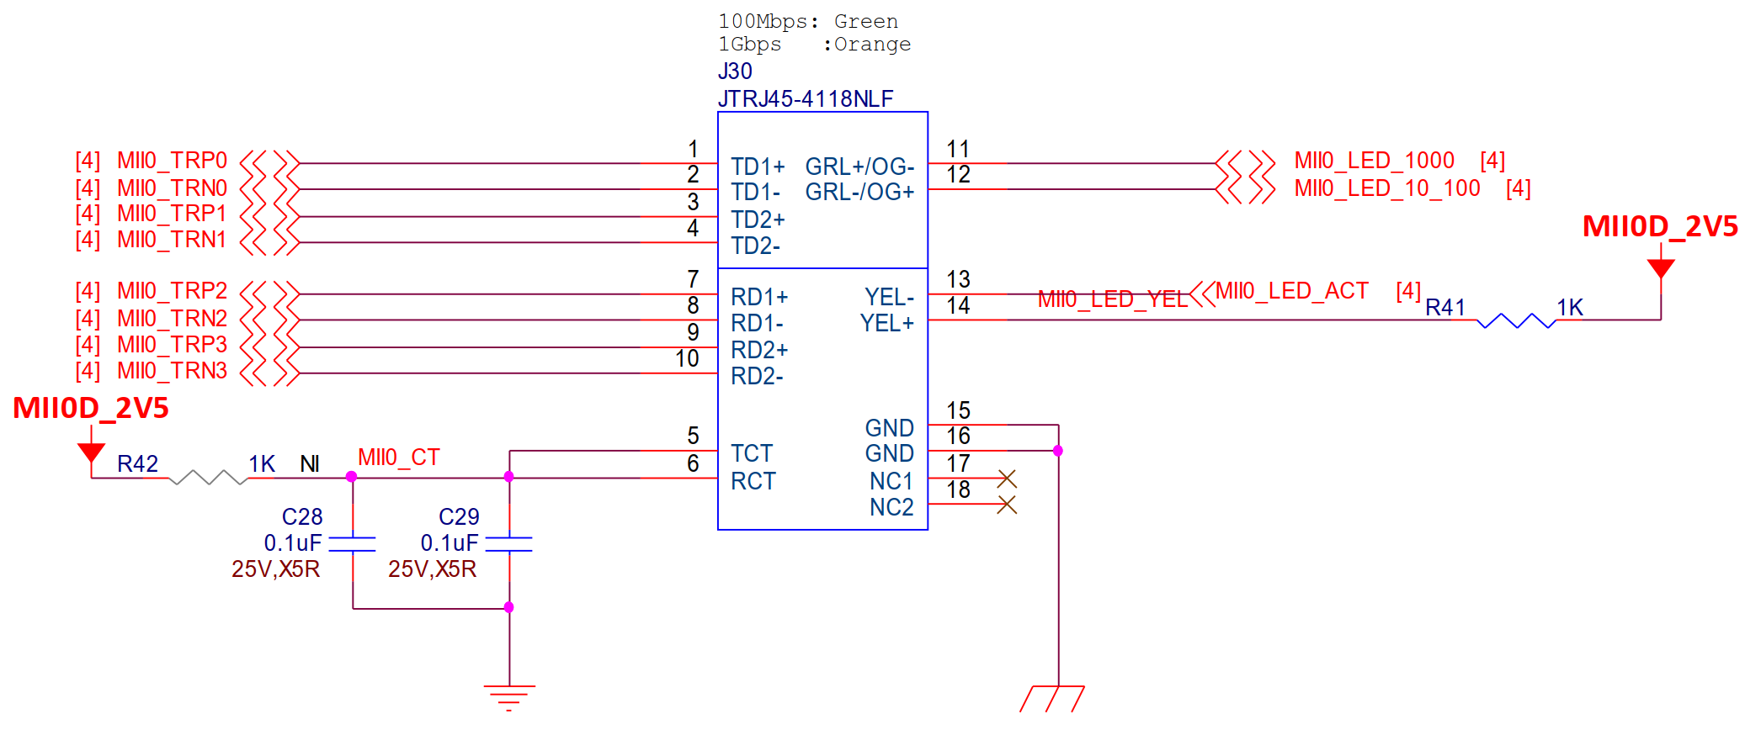

1. GBE Demo

### TF Card

It is strongly recommended that use the power source NVCC_SD2 output from J2.36 to power the memory card, and NVCC_SD2 DO NOT use to power other devices. Note that maximum current output is 150mA. Do not exceed 150mA at any time to avoid any unpredictable failure. If a apply is high than 150mA then another power supply should be design to support this.



1. TF Card Design Demo

### SOM Power-Up Enable

Suggest that using J2.60 (GND) on SOM to enable the 5V power supply for SOM as the following demo circuit. There will be no 5V power supply from the BTB connector on Baseboard while no SOM installed, it can protect SOM board from hog plug-in.



1. Power supply for SOM-IMX8MM LPD4

### PCIe Clock

In order to boot up the system smoothly, a PCIe differential clock input is necessary. For example, a 100MHz differential clock input to J1.43 and J1.45 on DEV-IMX8M-MINI is design to complete the PCIe function and boot up the system smoothly. If the baseboard does not need the PCIe function and the designer desire to remove the PCIe reference clock circuit. Please contact the sales for defining firmware.

The PCIe reference clock design for reference as follow.

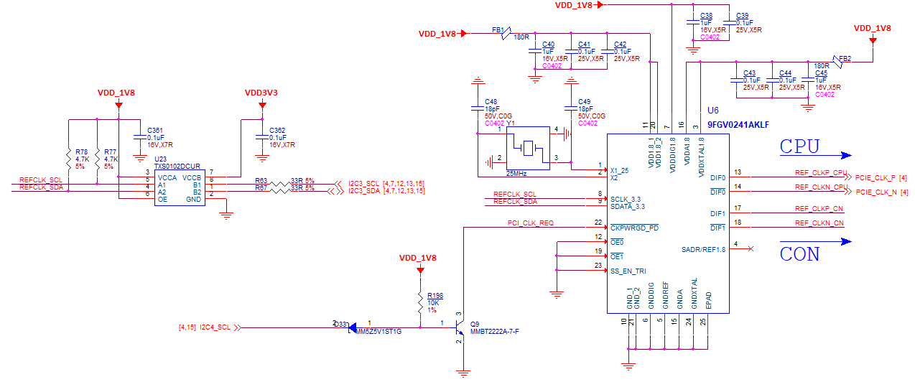

1. PCIe reference clock

### Serial Download

The USB port USB1 is used as connected port for the serial download function. The i.MX8M Mini/ Nano will enter serial download through USB1 when BOOT_MODE [1:0] is set to 01. Please remove the media card on uSDHC2 when the SOC is desired to enter serial download mode even the media card is empty.

The design for USB1 of the EVK as follow.

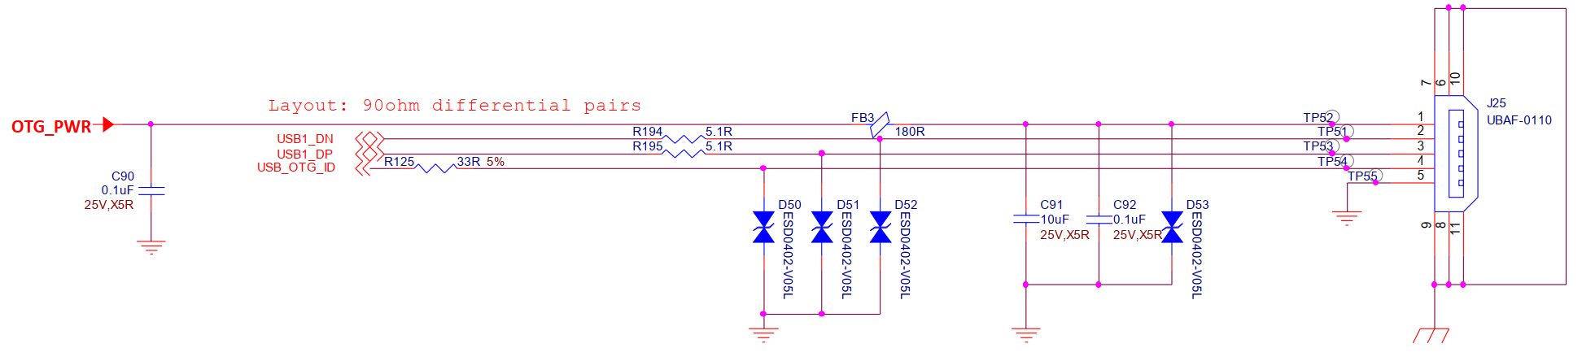

1. USB1 for EVK